Exploring Technology 10
Floor Plans Basics

For the following floor plan make some observations about the actual drawing techniques.

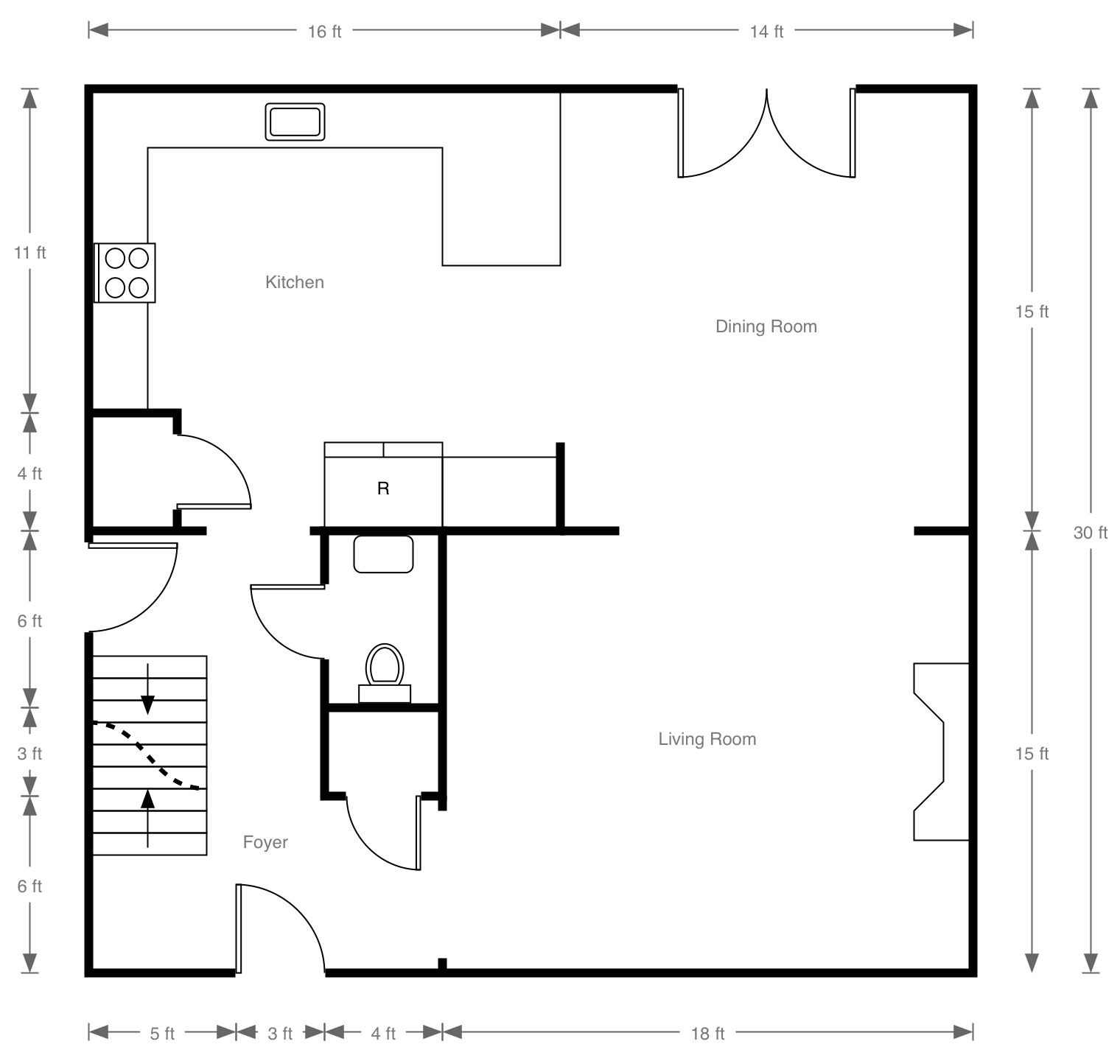

Make 5 observations about technical drawing based on the floor plan above:
- ______________________________________________________________________________________
- ______________________________________________________________________________________
- ______________________________________________________________________________________
- ______________________________________________________________________________________
- ______________________________________________________________________________________

